Configuring BRIO Connections for the Corporate Data Warehouse in DB2
Follow the steps below to create a BRIO .oce file (Open Catalog extension) connection for your machine:
Step 1: New Document
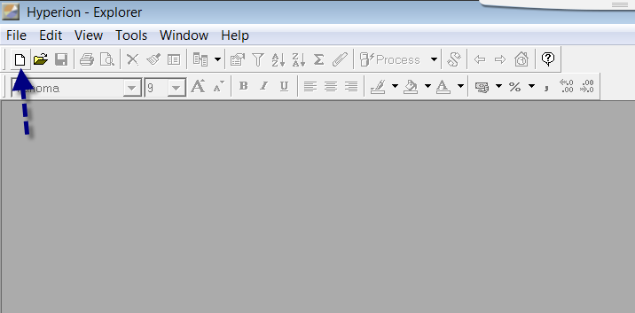
Step 2: New Database Connection File
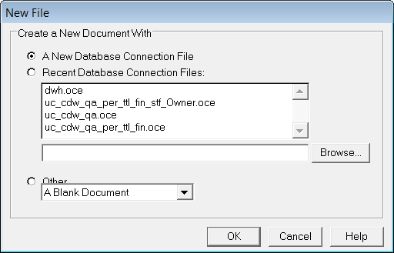
- Select A New Database Connection File
- Click OK

Step 3: Database Connection Wizard: Type of Connection
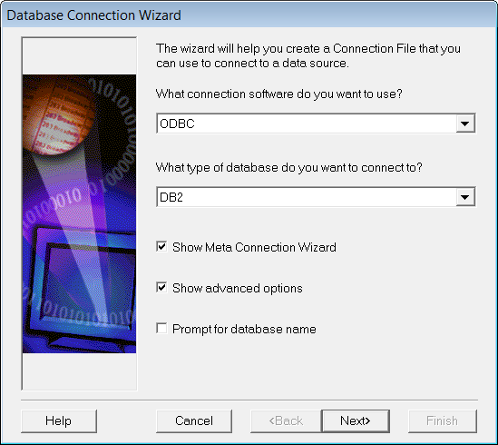

- Select ODBC for connection software
- Select DB2 for type of database
- Click Show Meta Connection Wizard
- Click Show advanced options
- Leave remaining boxes blank
- Click Next>
Step 4: Database Connection Wizard: Connect to the data source, enter user name….
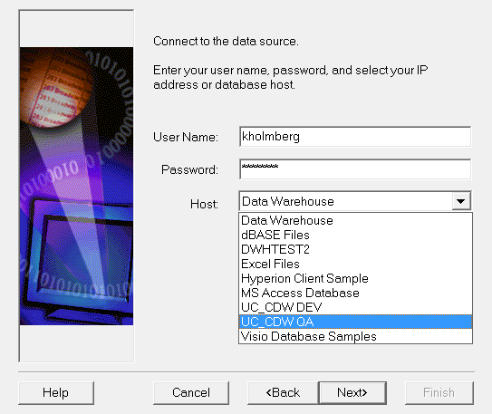
- Enter User Name as assigned (Your AD userid)
- Enter Password as assigned (Your AD password)
- Select UC_CDW_P as the Host (this will be available once the database is in production)
- Click Next>
Step 5: Meta Connection Wizard
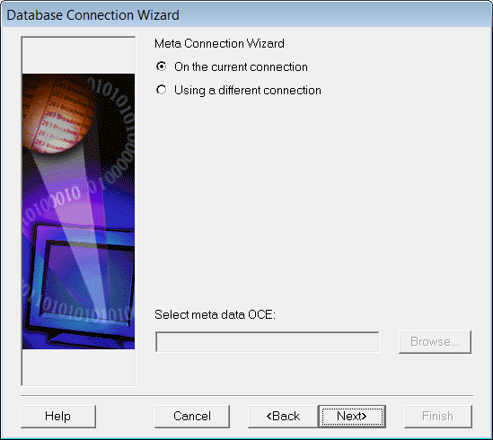
- Select On the Current connection
- Click Next>
Step 6: Meta Connection Wizard
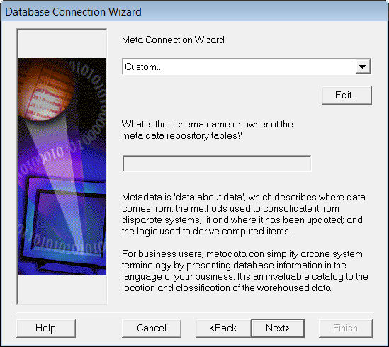
- Click Next>

Step 7: Meta Data Definition: Create the custom view for the desired application.
The custom views give users the opportunity to filter out tables not relevant to needs.
Underlying systems tables, for instance, are eliminated from table listings when the following steps are completed.
If there are some tables you are not authorized to read which have one of the owners you have selected, you will
see the tables listed but you won’t be able to create queries for them.
Users may wish to set up separate .oce files for separate systems, i.e. one for Financial, and one for Personnel.
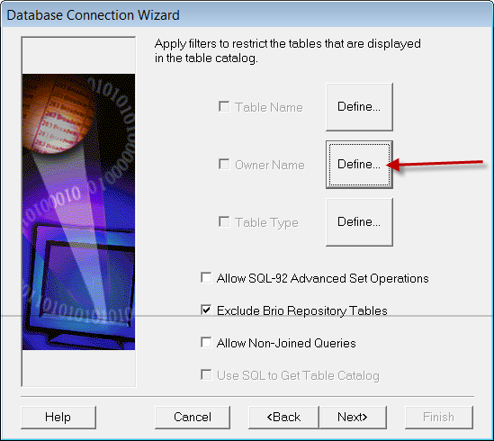
If you want to limit your view of the list of tables (the Table Catalog) to those for
which you have read access, click the Define button next to Owner Name.
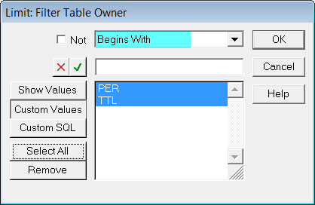
For Personnel, the table owner begins with either “PER” or “TTL”.
- Select “Begins With”
- Select “Custom Values”
- Enter “PER” and click the check box.
- Enter “TTL” and click the check box.
- Click “Select All”
- Click “OK”.
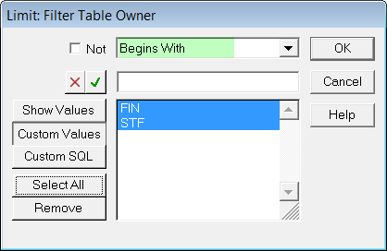
For Finance, the table owner begins with either “FIN” or “STF”. Follow the same steps as above.
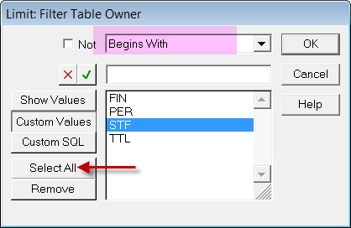
Or you can combine them into one .OCE file.
Alternate Way to Select Tables to be Displayed in Table Catalog
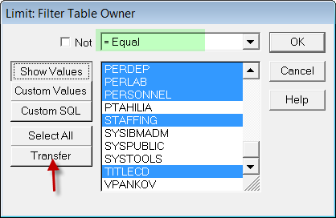
- Click on “Show Values”
- Select the specific schemas from the dropdown list
- Click OK
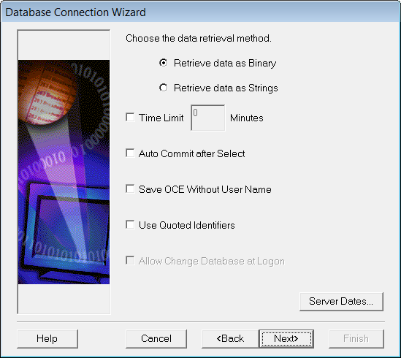
- Click Next>
- Click Next>
Step 8: Database Connection Wizard: Press Finish…
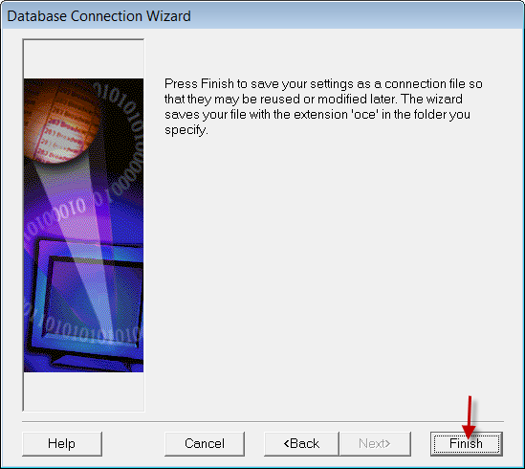
- Click Finish>
Step 9: Do you want to save your OCE?

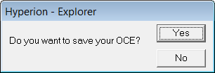
- Click Yes
Step 10: Save Open Catalog
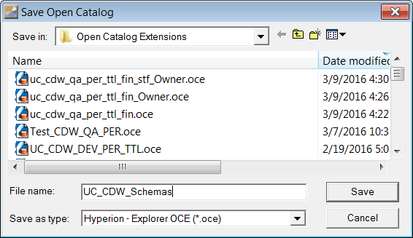
- Give the OCE a meaningful name and click Save.

